1. Declare a single-dimensional array of 5 integers inside the main method. Traverse the array to print the default values. Then accept records from the user and print the updated values of the array.

**package** ass6.example;

**import** java.util.Scanner;

**public** **class** que1 {

**public** **static** **void** main(String args[]) {

**int** a[]=**new** **int**[5];

**for**(**int** element : a) {

System.***out***.println("Default value:"+element);

}

**int** a2[]=**new** **int**[5];

Scanner sc=**new** Scanner(System.***in***);

System.***out***.println("Enter elements:");

**for**(**int** i=0;i<a2.length;i++) {

a2[i]=sc.nextInt();

}

System.***out***.print("Array elements are:");

**for**(**int** element:a2)

{

System.***out***.print(element+" ");

}

}

}

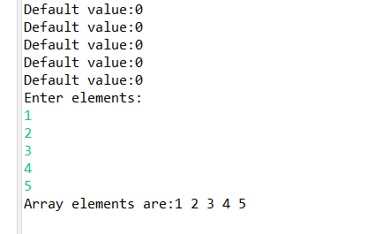

1. Declare a single-dimensional array of 5 integers inside the main method. Define a method named acceptRecord to get input from the terminal into the array and another method named printRecord to print the state of the array to the terminal.

**package** ass6.example;

**import** java.util.Scanner;

**public** **class** que2 {

**public** **static** **void** main(String[] args) {

**int**[] array = **new** **int**[5]; // Declare an array of 5 integers

// Accept records into the array

*acceptRecord*(array);

// Print the state of the array

*printRecord*(array);

}

// Method to accept records into the array

**public** **static** **void** acceptRecord(**int**[] array) {

Scanner scanner = **new** Scanner(System.***in***);

System.***out***.println("Enter 5 integer values:");

**for** (**int** i = 0; i < array.length; i++) {

System.***out***.print("Enter value for element " + (i + 1) + ": ");

array[i] = scanner.nextInt();

}

// Close the scanner

scanner.close();

}

// Method to print the state of the array

**public** **static** **void** printRecord(**int**[] array) {

System.***out***.println("Array elements are:");

**for** (**int** element : array) {

System.***out***.println(element);

}

}

}

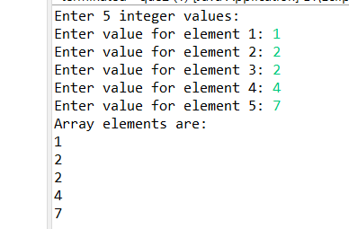

1. Write a program to find the maximum and minimum values in a single-dimensional array of integers.

**package** ass6.example;

**public** **class** que3 {

**public** **static** **void** main(String[] args) {

// **TODO** Auto-generated method stub

**int** a[]={1,2,3,4,5};

**int** min=a[0];

**int** max=a[0];

**for**(**int** i=0;i<a.length;i++) {

**if**(a[i]<=min) {

min=a[i];

}

**else**

max=a[i];

}

System.***out***.println("Minimum: "+min);

System.***out***.println("Maximum: "+max);

}

}

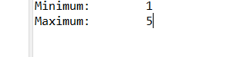

1. Write a program to remove duplicate elements from a single-dimensional array of integers.

**package** ass6.example;

**public** **class** que4 {

**public** **static** **void** main(String[] args) {

// **TODO** Auto-generated method stub

**int** a[]= {1,2,3,4,5,2};

System.***out***.print("Array elements are:");

**for**(**int** element: a) {

System.***out***.print(element+" ");

}

System.***out***.println();

System.***out***.print("Array elements after removing duplicates:");

**for**(**int** i=0;i<a.length;i++) {

**for**(**int** j=i+1;j<a.length;j++) {

**if**(a[i]==a[j])

a[i]=-1;

}

}

**for**(**int** i=0;i<a.length;i++) {

**if**(a[i]!=-1) {

System.***out***.print(a[i]+" ");

}

}

}

}



1. Write a program to find the intersection of two single-dimensional arrays.

**package** ass6.example;

**public** **class** que5 {

**public** **static** **void** main(String[] args) {

**int**[] array1 = {1, 2, 3, 4, 5};

**int**[] array2 = {4, 5, 6, 7, 8};

// Find the intersection of the two arrays

**int**[] intersection = *findIntersection*(array1, array2);

// Print the intersection elements

System.***out***.println("Intersection of the two arrays:");

**for** (**int** i = 0; i < intersection.length; i++) {

**if** (intersection[i] != -1) {

System.***out***.print(intersection[i] + " ");

}

}

}

**public** **static** **int**[] findIntersection(**int**[] array1, **int**[] array2) {

// Array to store the intersection elements, with a size equal to the smaller of the two input arrays

**int**[] tempIntersection = **new** **int**[Math.*min*(array1.length, array2.length)];

**int** index = 0;

// Initialize the tempIntersection array with -1 to indicate unused positions

**for** (**int** i = 0; i < tempIntersection.length; i++) {

tempIntersection[i] = -1;

}

// Nested loop to find common elements

**for** (**int** i = 0; i < array1.length; i++) {

**for** (**int** j = 0; j < array2.length; j++) {

**if** (array1[i] == array2[j]) {

// Check if the element is already in the tempIntersection array

**boolean** alreadyExists = **false**;

**for** (**int** k = 0; k < index; k++) {

**if** (tempIntersection[k] == array1[i]) {

alreadyExists = **true**;

**break**;

}

}

// If the element is not already in the tempIntersection array, add it

**if** (!alreadyExists) {

tempIntersection[index++] = array1[i];

}

}

}

}

**return** tempIntersection;

}

}



1. Write a program to find the missing number in an array of integers ranging from 1 to N.

**package** ass6.example;

**public** **class** que6 {

**public** **static** **void** main(String args[]) {

**int** a[]= {1,2,3,5,6};

System.***out***.print("Array elements are:");

**for**(**int** element:a) {

System.***out***.print(element+" ");

}

System.***out***.println();

**int** totsum=0;

**int** sum=0;

**for**(**int** i=0;i<a.length;i++) {

sum+=a[i];

}

**for**(**int** i=1;i<=6;i++) {

totsum+=i;

}

System.***out***.println("Missing element is:"+(totsum-sum));

}

}

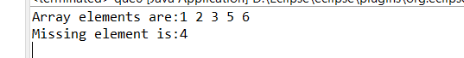

1. Declare a single-dimensional array as a field inside a class and instantiate it inside the class constructor. Define methods named acceptRecord and printRecord within the class and test their functionality.

**package** ass6.example;

**import** java.util.Scanner;

**class** Array1{

**int** a[];

**public** Array1(){

a=**new** **int**[5];

}

**public** **void** acceptRecord() {

Scanner sc=**new** Scanner(System.***in***);

System.***out***.println("Enter array elements:");

**for**(**int** i=0;i<a.length;i++) {

a[i]=sc.nextInt();

}

}

**public** **void** printRecord() {

System.***out***.println("Array elements are:");

**for**(**int** ele:a) {

System.***out***.println(ele);

}

}

}

**public** **class** que7 {

**public** **static** **void** main(String[] args) {

// **TODO** Auto-generated method stub

Array1 obj=**new** Array1();

obj.acceptRecord();

obj.printRecord();

}

}

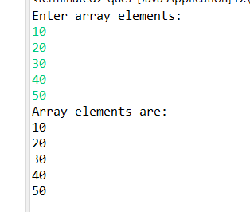

1. Modify the previous assignment to use getter and setter methods instead of acceptRecord and printRecord.

**package** ass6.example;

**import** java.util.Scanner;

**class** Array2{

**private** **int** a[];

**public** Array2(**int** size) {

a=**new** **int**[size];

}

**public** **int**[] getA() {

**return** a;

}

**public** **void** setA(**int**[] a) {

**this**.a = a;

}

}

**public** **class** que8 {

**public** **static** **void** main(String[] args) {

// **TODO** Auto-generated method stub

Array2 obj=**new** Array2(5);

System.***out***.println("Enter array size:");

Scanner sc = **new** Scanner(System.***in***);

**int** size =sc.nextInt();

**int** a2[]=**new** **int**[size];

System.***out***.println("Enter array elements:");

**for**(**int** i=0;i<a2.length;i++) {

a2[i]=sc.nextInt();

}

obj.setA(a2);

**int** a[]=obj.getA();

System.***out***.println("Array elements are:");

**for** (**int** ele :a) {

System.***out***.println(ele);

}

}

}

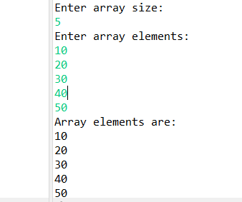

1. You need to implement a system to manage airplane seat assignments. The airplane has seats arranged in rows and columns. Implement functionalities to:

* Initialize the seating arrangement with a given number of rows and columns.
* Book a seat to mark it as occupied.
* Cancel a booking to mark a seat as available.
* Check seat availability to determine if a specific seat is available.
* Display the current seating chart.